## Class-wise Metrics:

| Class 0 (Canine (13)):  Precision: 0.952  Recall: 0.973  mAP@50: 0.987  mAP@50-95: 0.741 | Class 1 (Canine (23)):  Precision: 0.990  Recall: 0.942  mAP@50: 0.984  mAP@50-95: 0.743 | Class 2 (Canine (33)):  Precision: 0.941  Recall: 0.965  mAP@50: 0.973  mAP@50-95: 0.712 | Class 3 (Canine (43)):  Precision: 0.968  Recall: 0.982  mAP@50: 0.983  mAP@50-95: 0.738 |
| --- | --- | --- | --- |
| Class 4 (Central Incisor (21)):  Precision: 0.981  Recall: 0.990  mAP@50: 0.988  mAP@50-95: 0.770 | Class 5 (Central Incisor (41)):  Precision: 0.970  Recall: 0.947  mAP@50: 0.990  mAP@50-95: 0.623 | Class 6 (Central Incisor (31)):  Precision: 0.940  Recall: 0.955  mAP@50: 0.977  mAP@50-95: 0.609 | Class 7 (Central Incisor (11)):  Precision: 0.963  Recall: 1.000  mAP@50: 0.993  mAP@50-95: 0.760 |
| Class 8 (First Molar (16)):  Precision: 0.976  Recall: 1.000  mAP@50: 0.986  mAP@50-95: 0.799 | Class 9 (First Molar (26)):  Precision: 0.973  Recall: 0.990  mAP@50: 0.985  mAP@50-95: 0.766 | Class 10 (First Molar (36)):  Precision: 0.988  Recall: 0.987  mAP@50: 0.986  mAP@50-95: 0.829 | Class 11 (First Molar (46)):  Precision: 0.961  Recall: 0.988  mAP@50: 0.987  mAP@50-95: 0.832 |
| Class 12 (First Premolar (14)):  Precision: 0.963  Recall: 0.980  mAP@50: 0.984  mAP@50-95: 0.700 | Class 13 (First Premolar (34)):  Precision: 0.956  Recall: 0.975  mAP@50: 0.981  mAP@50-95: 0.736 | Class 14 (First Premolar (44)):  Precision: 0.976  Recall: 0.991  mAP@50: 0.990  mAP@50-95: 0.752 | Class 15 (First Premolar (24)):  Precision: 0.949  Recall: 0.940  mAP@50: 0.971  mAP@50-95: 0.686 |
| Class 16 (Lateral Incisor (22)):  Precision: 0.971  Recall: 0.973  mAP@50: 0.985  mAP@50-95: 0.710 | Class 17 (Lateral Incisor (32)):  Precision: 0.955  Recall: 0.958  mAP@50: 0.977  mAP@50-95: 0.683 | Class 18 (Lateral Incisor (42)):  Precision: 0.964  Recall: 0.952  mAP@50: 0.974  mAP@50-95: 0.679 | Class 19 (Lateral Incisor (12)):  Precision: 0.977  Recall: 0.991  mAP@50: 0.994  mAP@50-95: 0.687 |
| Class 20 (Second Molar (17)):  Precision: 0.972  Recall: 1.000  mAP@50: 0.993  mAP@50-95: 0.803 | Class 21 (Second Molar (27)):  Precision: 0.985  Recall: 0.991  mAP@50: 0.990  mAP@50-95: 0.791 | Class 22 (Second Molar (37)):  Precision: 0.990  Recall: 0.990  mAP@50: 0.991  mAP@50-95: 0.819 | Class 23 (Second Molar (47)):  Precision: 0.964  Recall: 0.990  mAP@50: 0.974  mAP@50-95: 0.843 |
| Class 24 (Second Premolar (15)):  Precision: 0.972  Recall: 1.000  mAP@50: 0.988  mAP@50-95: 0.730 | Class 25 (Second Premolar (25)):  Precision: 0.978  Recall: 0.971  mAP@50: 0.987  mAP@50-95: 0.705 | Class 26 (Second Premolar (35)):  Precision: 0.964  Recall: 0.990  mAP@50: 0.981  mAP@50-95: 0.754 | Class 27 (Second Premolar (45)):  Precision: 0.922  Recall: 0.980  mAP@50: 0.982  mAP@50-95: 0.774 |
| Class 28 (Third Molar (18)):  Precision: 0.955  Recall: 0.988  mAP@50: 0.983  mAP@50-95: 0.772 | Class 29 (Third Molar (28)):  Precision: 0.988  Recall: 0.982  mAP@50: 0.986  mAP@50-95: 0.739 | Class 30 (Third Molar (38)):  Precision: 0.982  Recall: 0.977  mAP@50: 0.985  mAP@50-95: 0.799 | Class 31 (Third Molar (48)):  Precision: 0.990  Recall: 1.000  mAP@50: 0.995  mAP@50-95: 0.832 |

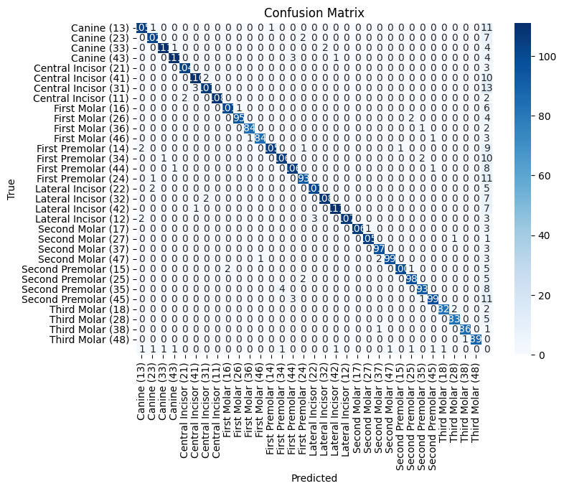

## Sample prediction images showing bounding boxes + FDI IDs

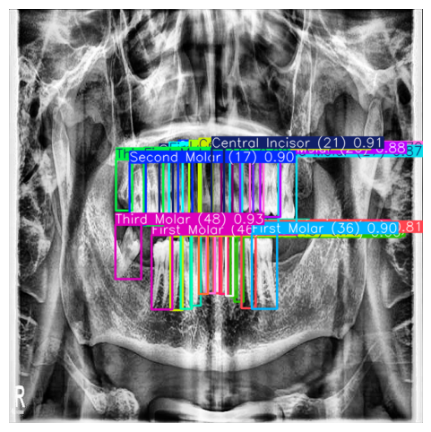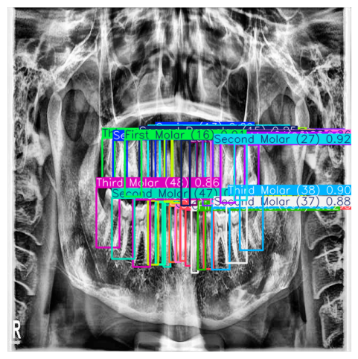

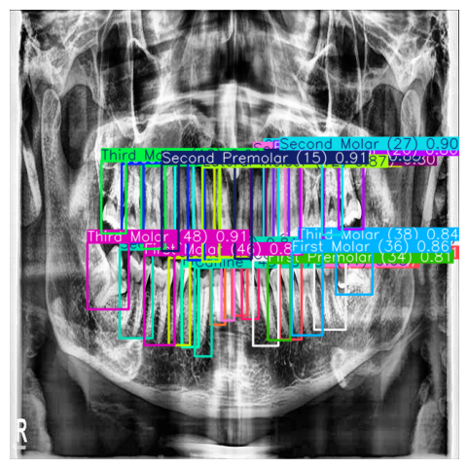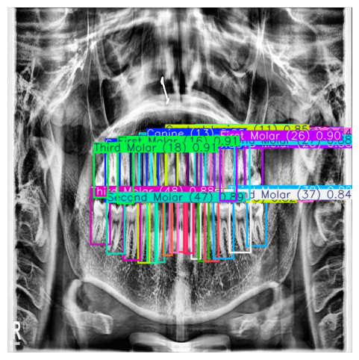

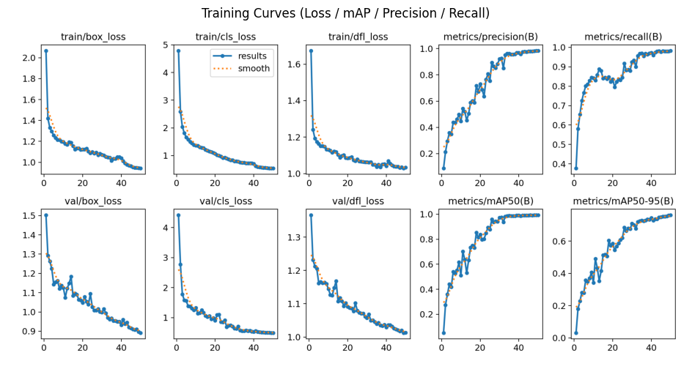

### **Summary of Approach**

In this notebook, we develop a **YOLO-based object detection model** for identifying and numbering teeth in dental X-rays according to the **FDI numbering system**.

The workflow includes:

1. **Data Preparation** – Organizing X-ray images and YOLO-format labels into train/val/test splits.
2. **Model Training** – Training YOLOv8 on the dataset to detect individual teeth.
3. **Evaluation** – Computing confusion matrices, per-class performance metrics, and visualizing training curves (loss, accuracy, precision, recall).
4. **Inference** – Running predictions on test images and saving results with bounding boxes.
5. **Post-Processing** – Refining predictions to ensure anatomical correctness by separating upper/lower arches, dividing left/right quadrants, sorting teeth, and assigning **FDI IDs** sequentially